**Name:** Anshul Shirbhate

**Roll No:** D – 5

**Practical No:** 6

**Practical Name/Aim:** Configure network using Cisco packet tracer software and show packet transmission from source to destination.

**Steps:**

1. Select a Hub/Switch from the hubs section.

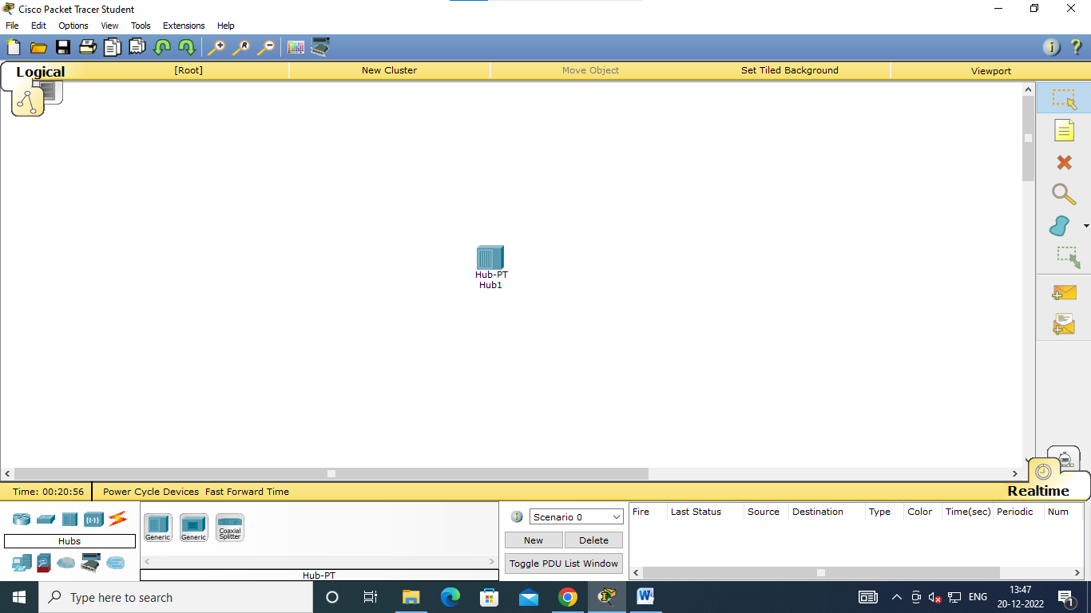

2. Select computers from end devices.

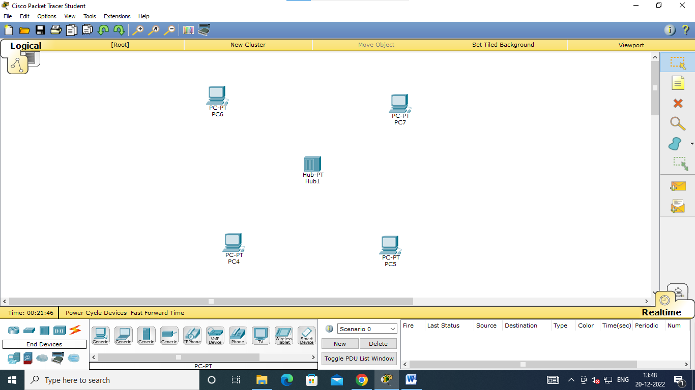

3. Connect the computers to the hub using the connection cable which in this case is automatically choose connection type.

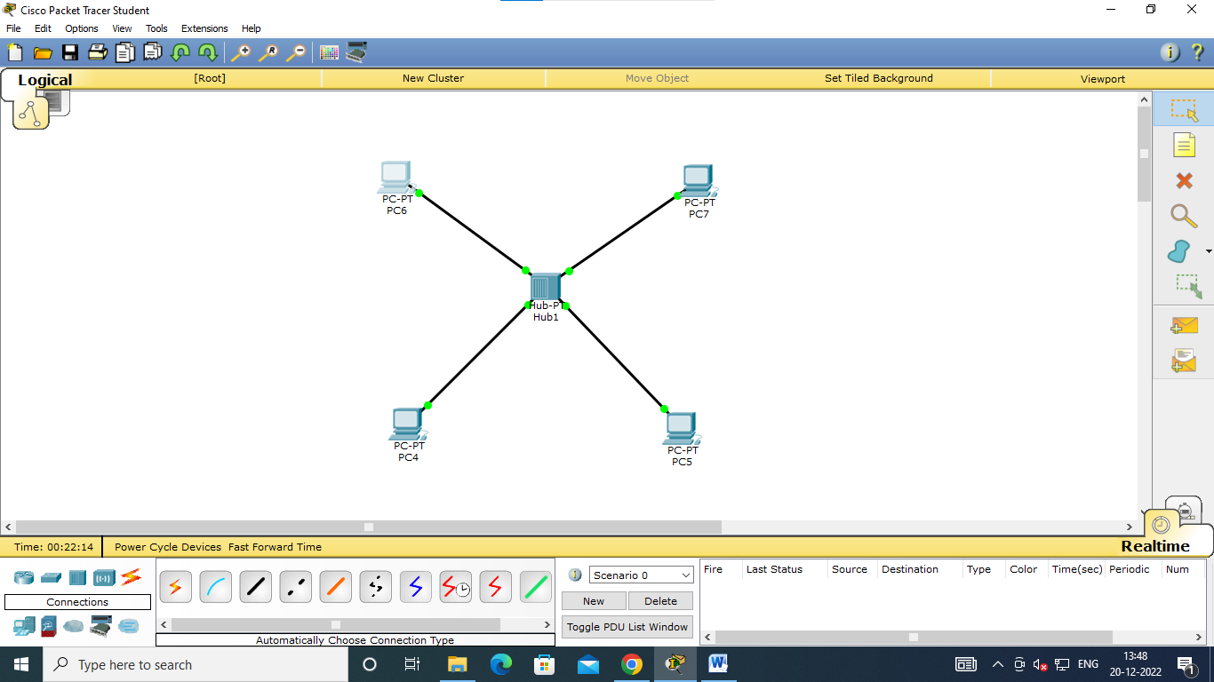

4. Configure IP address for every PC in the network.

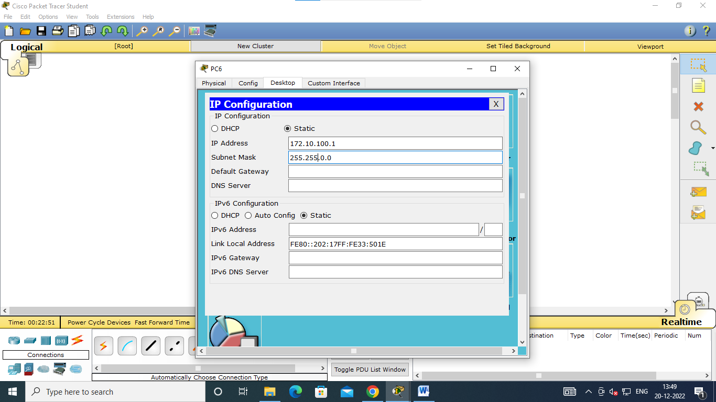

5. After setting the IP addresses, we can send packets from one computer to another. Therefore select a PDU from the PDU section and drag that PDU from source pc to destination pc.

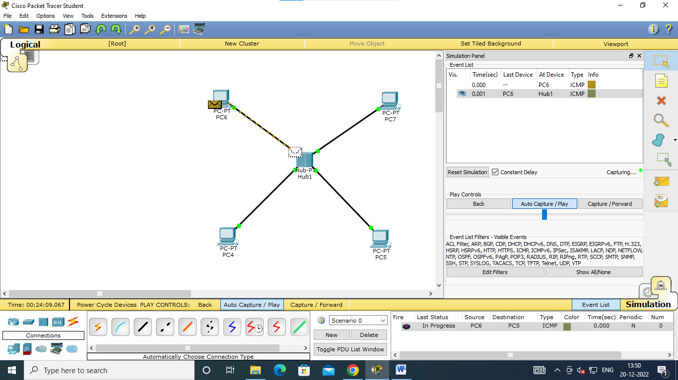

6. The packet get set to the hub first then the hub sends the packet to all the devices on the network but only the device which is expecting the packet accepts the packet and the others rejects the packet.

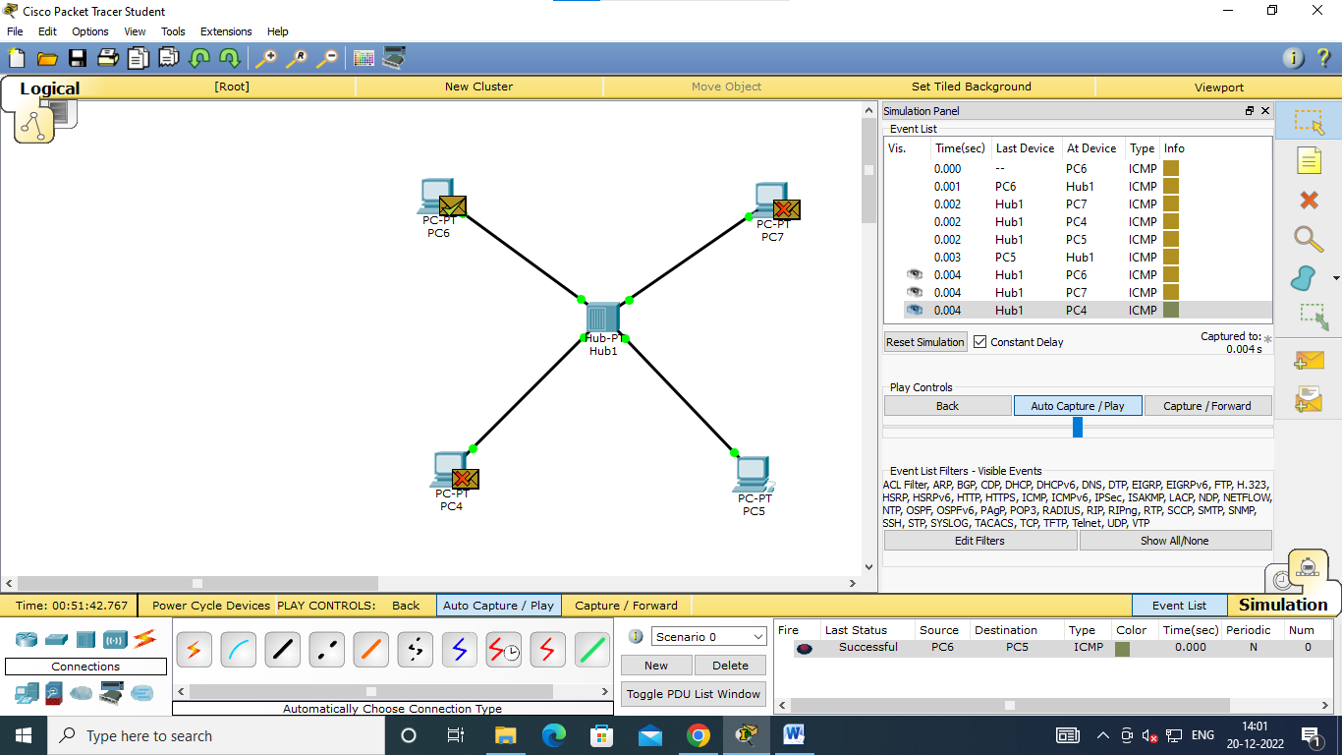

**Conclusion:** Connection established successfully between Source and Destination.